Incoming 8th French Summer Work 2024
Grammar Review:
- Explore 25 new nouns- find out their French translation and complete the following chart

NEW NOUN (English & French translation) | Definite article  (Singular & Plural) | Indefinite article (Singular & Plural) | Possessive article (MY) (Singular & Plural) | Possessive article (YOUR) (Singular & Plural) | Possessive article (HIS/HERS) (Singular & Plural)
Car voiture (f) feminin | LA/LES | UNE/DES | MA/MES | TA/TES | SA/SES

- Choose 10 “ER”, 5 “IR” & 5 “RE” verbs from the REGULAR VERBS CHART – conjugate all 20 verbs using the French Subject Pronouns – see below chart to recreate.

JE | NOUS
TU | VOUS
IL/ELLE | ILS/ELLES

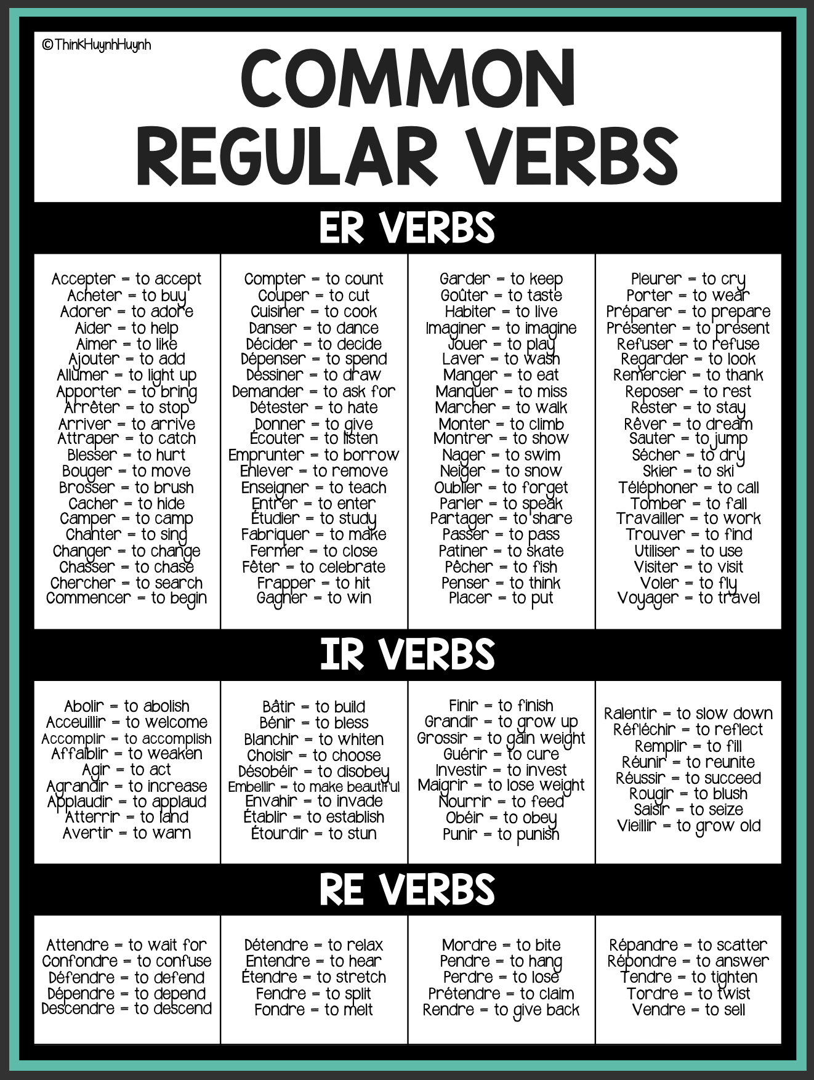
LISTNING:

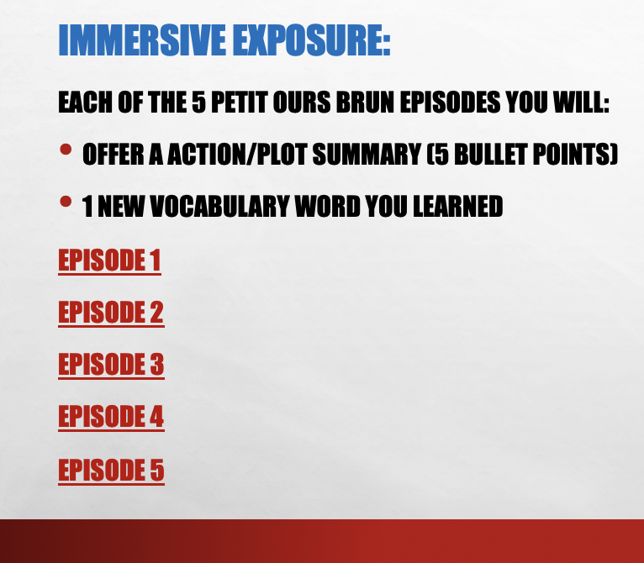

READING:

